**­R Computer Lab #2**

8,6 or 21.5/25

**Student**: Guðrún Alma Einarsdóttir

**Partner**: Erna Guðrún Björnsdóttir

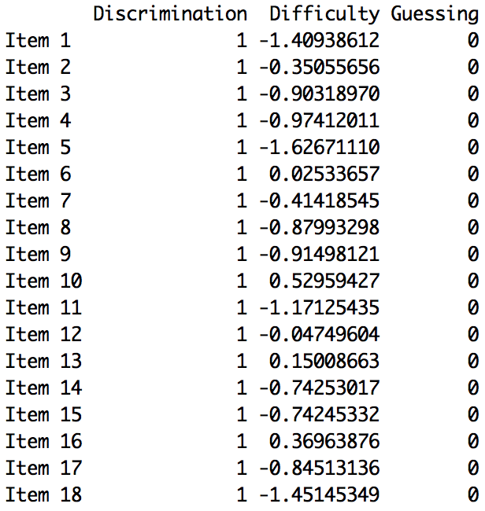**1. a)** Item number 5 was the easiest to answer -1.626 and item 10 was the hardest to answer 0.529.

**b)** The spot where the probability of correctly answering item 5 is between -1.88 and -1.37 with 95% confidence. -1. Intrepretation is incorrect, please see the answer key  
  
-1.626 - 1.96 x 0,13 = -1.88

-1.626 + 1.96 x 0,13 = -1.37

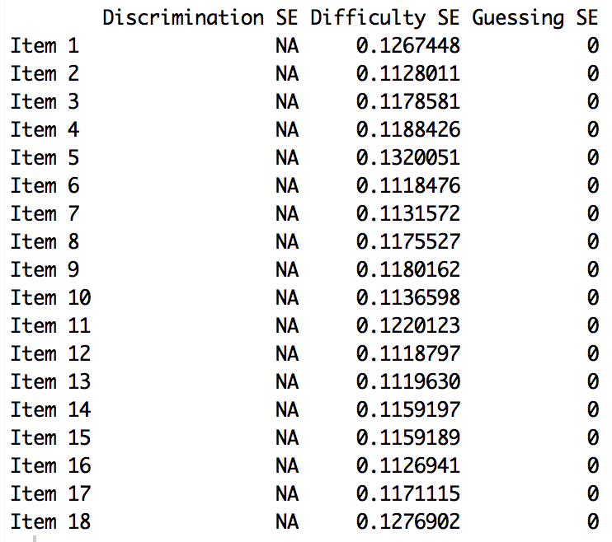

**c)** 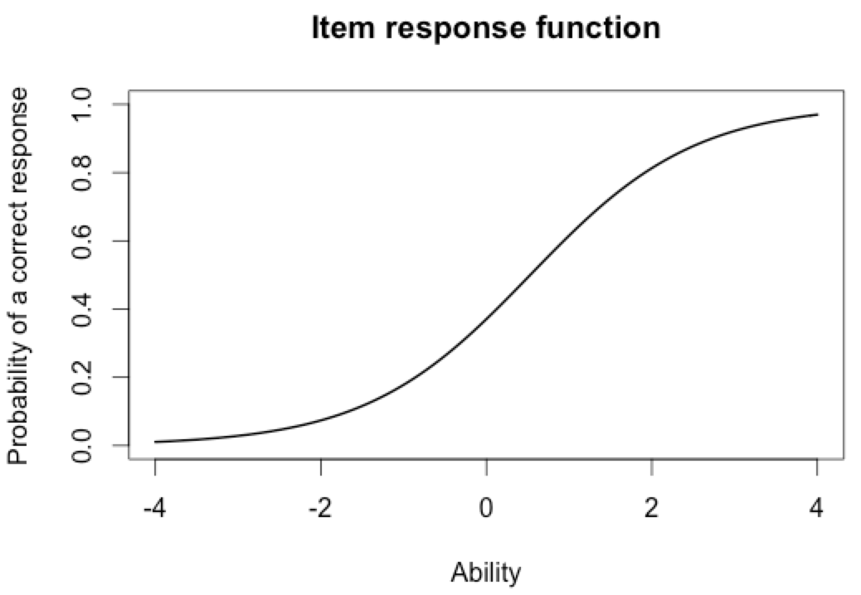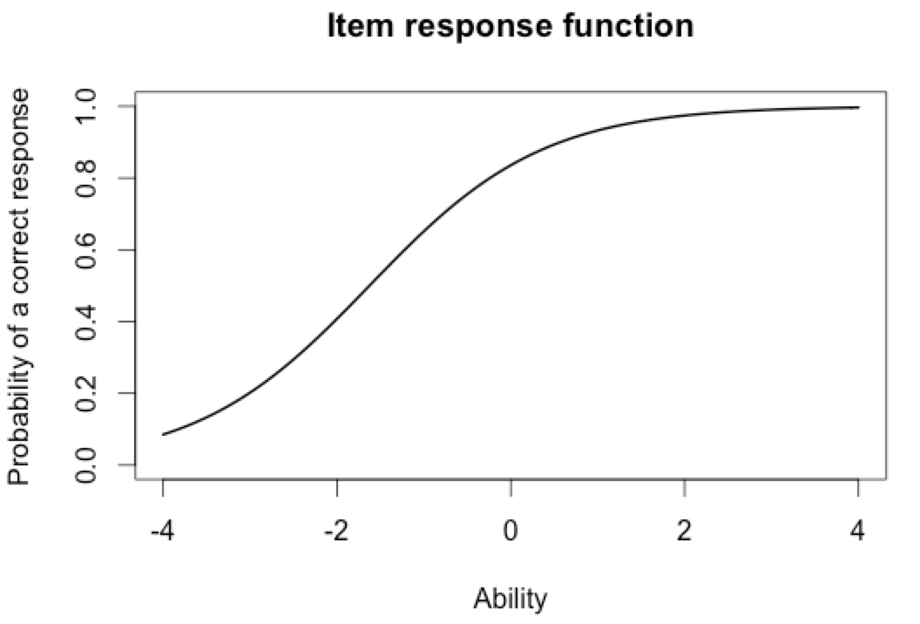 Item 5 Item 10

Black line: Item 5

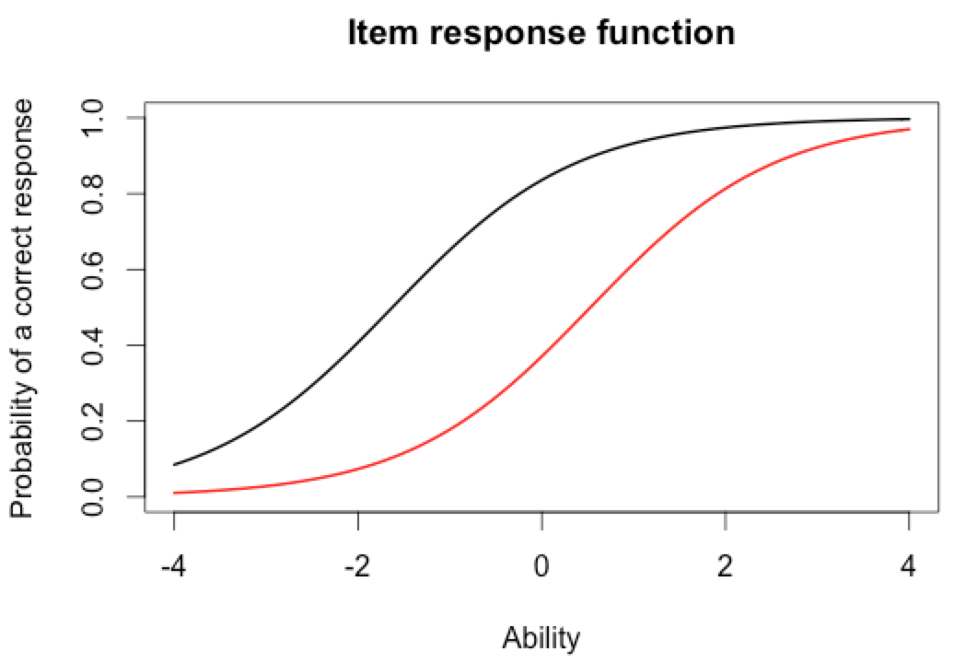Red line: Item 10

**d)** For the easiest item it will be around 0.8 and for the hardest item around 0.3. 2

**e)** The score of the person who did best on the test was 3.99. The score of the person who did the worst on the test was -3.99.

> which.max(est_abl$est) # Prints out the person with the maximum score

[1] 49  
 est sem n

49 3.999921 2.204373 18

> which.min(est_abl$est) # Prints out the person minimum score

[1] 393

est sem n

393 -3.999947 1.225286 18

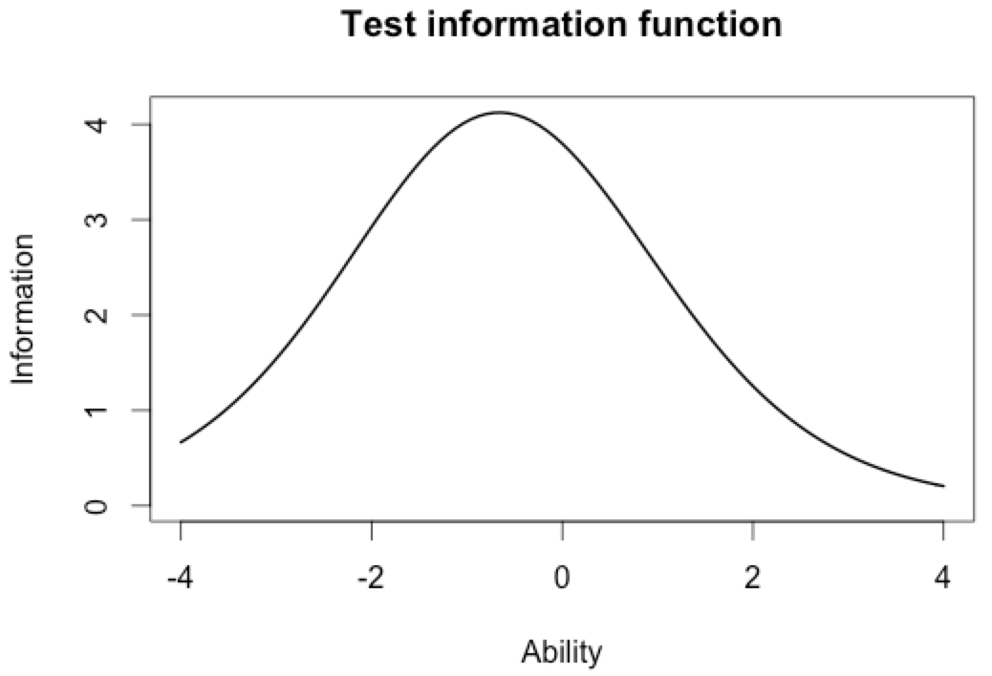

**f)** The person that did best on the test, his ability estimate was between -0,322 and 8,30 with 95% confidence. -1, interpretation incorrect, please see the answer key

3.99 - 1.96 x 2.2 = -0,322

3.99 + 1.96 x 2.2 = 8.302

**2. a)** Items chosen were: 1, 7 and 17.

**b)** Item 1: Black, Item 7: Red, Item 17: Green.

plot(iif(est_params[c(1,7,17),]), co = NA)

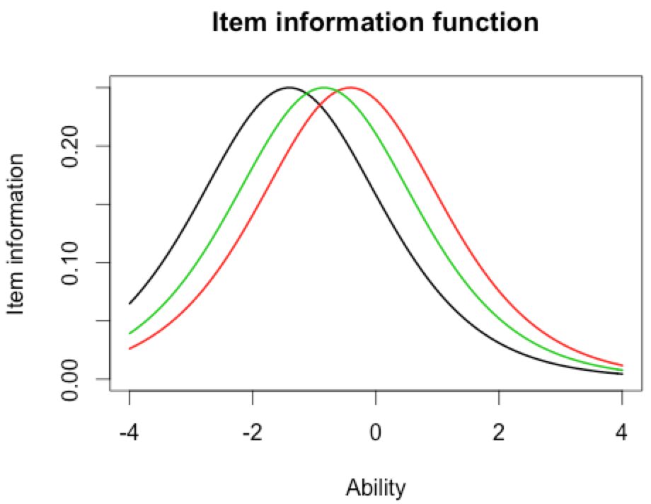**c)** ***Same***: All the items together have the most information located between -2 and 0. ***Different***: All the items have different ability estimate.

Item’s don’t have ability estimates. You should discuss shape and location of this item. Shapes are the same, location different. -1

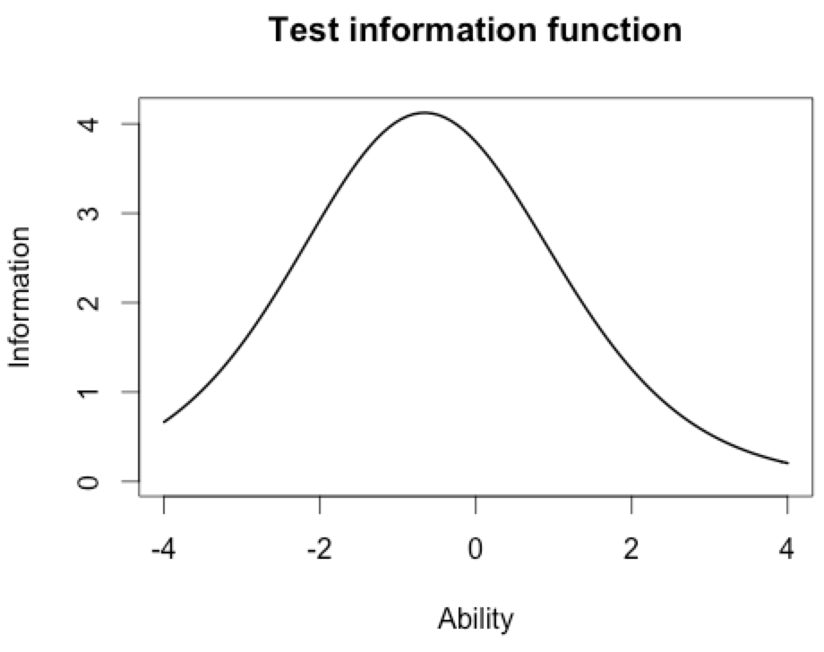**d)** plot(tif(est_params))

**e)** The majority of the information is located between -2 and 1.

**3. a)** Item 8 had the highest discrimination 2.288 and item 12 had the lowest discrimination 0.332.

**b)** No not quite, in the 2-PL model item 1 is the easiest but item 10 is still the hardest item in both models.

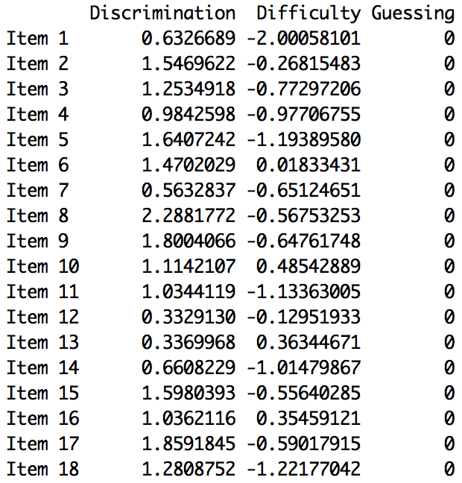

**c)** The correlation between the Rasch model and the 2-PL model is 0.97. If you are high on ability on the Rasch model you will be high aswell in ability on the 2-PL model because the correlation between the models is very high.  
  
> cor(twopl_abl$est,est_abl$est)

[1] 0.9709497

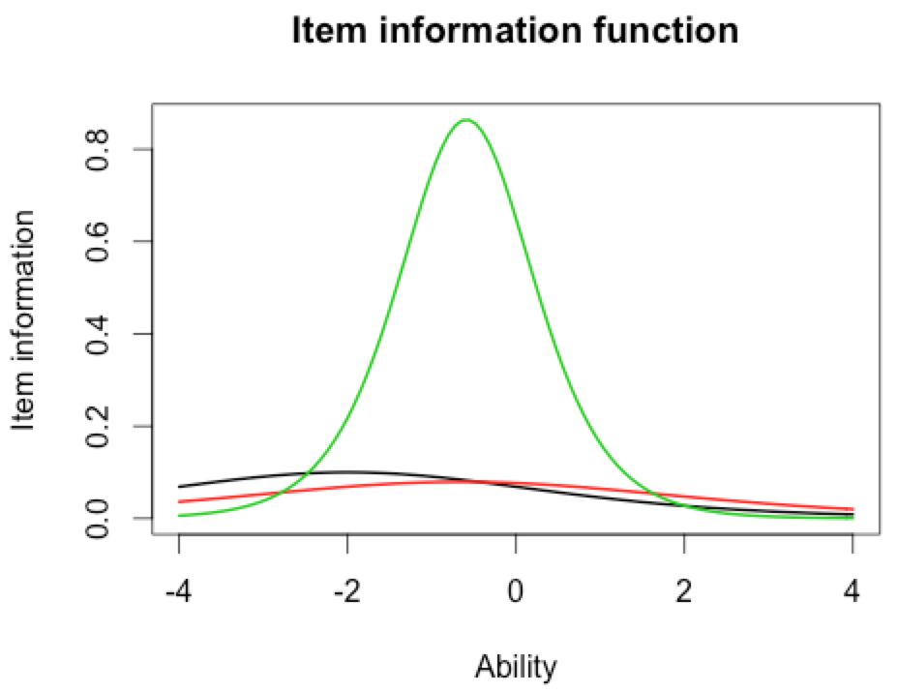**d)** > plot(iif(twopl_params[c(1,7,17),]), co = NA)

**e)**  The items do not have the same discrimination and difficulty. In the 2-PL model we have the discriminating factor that helps us discriminate more easily between items information and ability estimate. The Rasch model only tells us about the item location/difficulty.

This is true but what specifically about the shape and location of these graphs is different between the models. Yes more parameters are being estimated but how does that manifest itself in these plots? -.5